Python Loops Worksheet

1. How many times does the following loop execute, and what is its output?

count = 1

while count <= 7:

print(count)

count = count + 1

**OUTPUT:**

1

2

3

4

5

6

7

**END** Loop executes 7 times.

2. How many times does the following loop execute, and what is its output?

count = 0

while count <= 5:

print(str(count) + ',')

count += 1

**OUTPUT:**

0,

1,

2,

3,

4,

5,

**END** Loop executes 6 times.

3. How many times does the following loop execute, and what is its output?

count = 1

while count < 13:

print('$' + str(count) + '.00')

count = count + 2

**OUTPUT:**

$1.00

$4.00

$6.00

$8.00

$10.00

$12.00

**END** Loop executes 6 times.

4. The following code segment is supposed to output the average of the 5 numbers input by the user. Instead, it simply outputs the sum of all the numbers. What's wrong with the code segment? Change the code so that it works correctly.

sum = 0

count = 5

**numbers_entered = 0**

while count > 0:

numbers_entered **+**= 1

number = float(input( ))

sum = sum + number

count = count - 1

answer = sum / numbers_entered

print(answer)

5. How many times does the following loop execute, and what is its output?

y = 0

for x in range(1, 6):

y = x + y

print(x, '\t', y)

**OUTPUT:**

1 1

2 3

3 6

4 10

5 15

**END** Loop executes 5 times.

6. How many times does the following loop execute, and what is its output?

for counter in range(14, 7):

print(counter)

**OUTPUT:**

**END** Loop executes 0 times.

7. Write a code segment using a "while" loop that outputs the numbers from -10 to 10.

num = -10

while num <= 10:

print(num)

num += 1

8. Write a code segment that asks a user to enter a number between 0 and 100, inclusive. The input should be done in a "while loop" that repeats if the user enters a value outside the requested range. Output should simply show the number.

SAMPLE RUN:

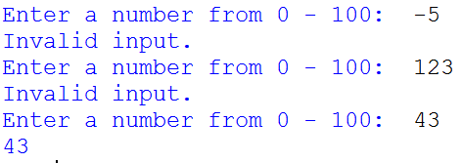

while True:

num = int(input(“Enter a number from 0 – 100: “))

if num >= 0 and num <= 100:

print(num)

break

else:

print(“Invalid input”)

9. Write a code segment that displays a chart of Fahrenheit and Celsius equivalents, from 0° to 100°F, by 10°. The values should appear in two columns as integers, with column headers.

SAMPLE RUN:

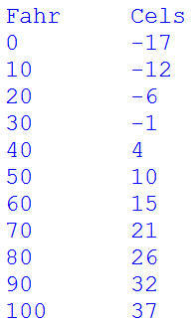

fahr_celsius = [(x, int((x - 32) * 5 / 9)) for x in range(0, 101, 10)]

print("Fahr \t Cels")

for f, c in fahr_celsius:

print("{0:<3} \t {1:<3}".format(f, c))